Edward Auttonberry

**Lab 1: Using the Vernier Lab Pro Interface and the Logger Pro Data Collection Software**

6/16/2018

PHYS 261 – 005

With:

Zac Davis

and

Tyler Perry

**Objective**

The objective of this lab for us was to familiarize ourselves with interfacing with the Lab Pro using the Logger Pro collection software. We were to become familiar with the processes of finding the average value in a set of continuous data and finding the standard deviation about that average. We were also to learn the user interfaces and tools for Excel and Logger Pro, such as graphs and tables in the former, and the Statistic and Linear fit tools in the latter.

**Theory**

The theory being tested in this is that the temperature of an object will change at a rate proportional to the difference in temperature between the source of heat and another object. To do this, we needed to know the temperature of the thermometer rod at equilibrium with the room temperature, the temperature of the object that sources the heat (a hand), and we will need to measure the temperature of the thermometer as it increases during contact with the heat source. Using the data, we would find the standard deviation over the set of data.

**Procedure**

The procedure for this lab involved the Lab-Pro measurement tool and the Logger Pro software, and a thermometer rod connected to the Lab-Pro, the temperature of which is being measured. Using these utilities, two separate sets of data were recorded. For the first set of data, we let the thermometer alone while the Lab-Pro collected two measurements a second for 100 seconds. For the second set, we let the Lab-Pro collect at the same rate for 200 seconds. We left the thermometer alone for about 10 seconds to get a clear idea of where the equilibrium temperature stands to compare with the rest of the data collected. After that, one of us grabbed the thermometer firmly with our hand for the remainder of the collection duration.

**Data**

**Set A:**

Shown below is the results of the first measurement in Logger-Pro

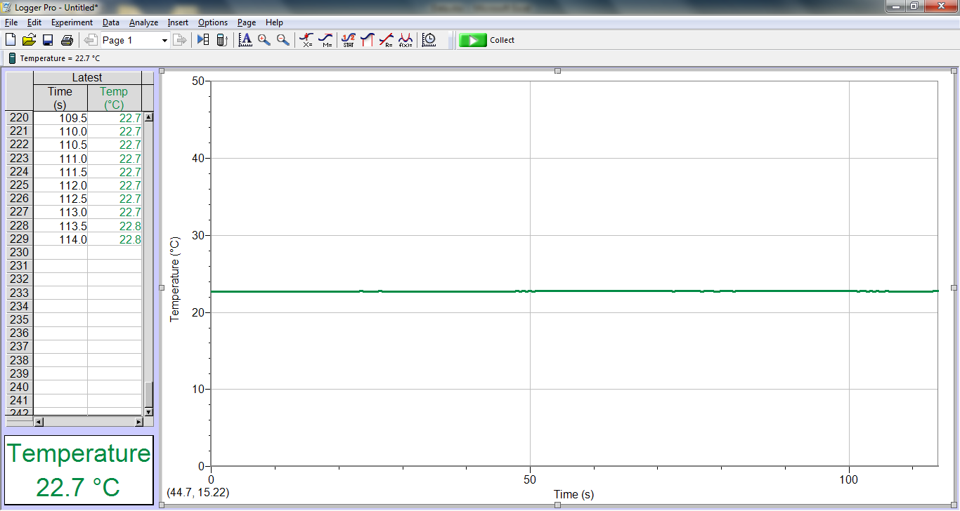

**Figure 1.** The scale is quite far out, but even at from this perspective it is visible that deviation from about 22.6 OC is minimal.

**Set B:**

Below is the LoggerPro results of Procedure B when the thermometer was grasped by a hand.

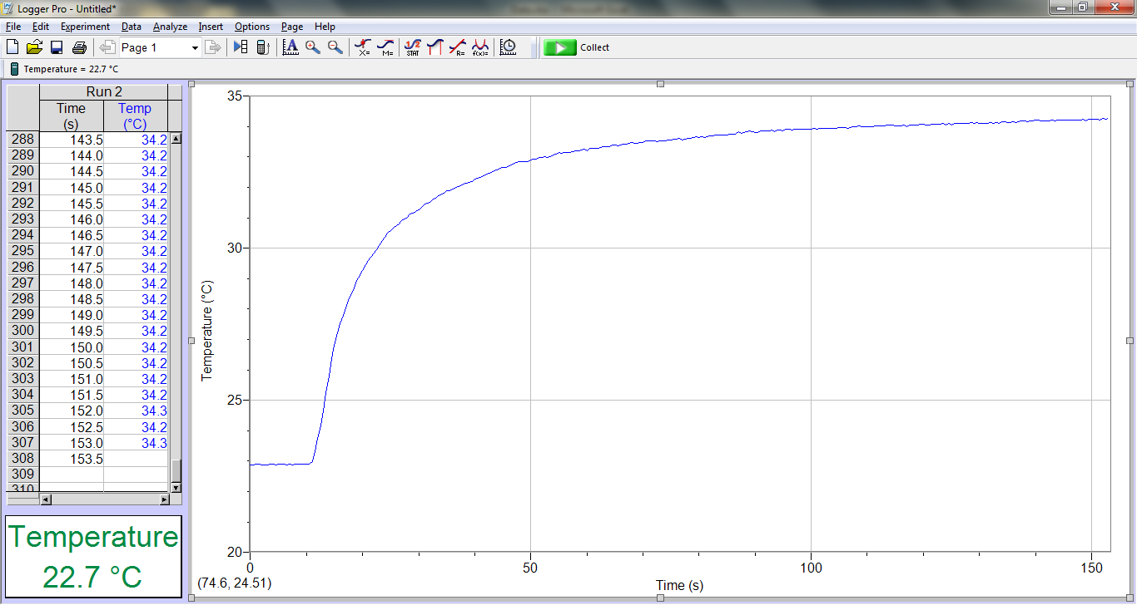

**Figure 2.** At about 10 seconds time, the thermometer was grasped firmly in hand. Before that point, the temperature readings were fairly constant as in Procedure A, but afterwards the temperature began to increase at a polylogarithmic rate.

**Analysis**

**Procedure A**

Below is a sample of the readings from Procedure A.

|  |  |
| --- | --- |
| time (sec) | T (°C) |
| 4 | 22.70834 |
| 4.5 | 22.70834 |
| 5 | 22.73161 |
| 5.5 | 22.73161 |
| 6 | 22.73161 |
| 6.5 | 22.73161 |
| 7 | 22.70834 |
| 7.5 | 22.73161 |
| 8 | 22.70834 |
| 8.5 | 22.73161 |
| 9 | 22.70834 |
| 9.5 | 22.73161 |
| 10 | 22.73161 |
| 10.5 | 22.70834 |
| 11 | 22.73161 |

**Table 1.** A sample of the readings from Procedure A. The selection contains 15 ping points from second 4 to second 11.

I will be using this sample to find an average of the temperature. According to LoggerPro, the average temperature of the selection was 22.7223 °C.

The equation for finding the mean of a set of data is

$\overline{T}=\frac{\sum_{i=0}^{N}{T}}{N}$ Eq.(1-1)

Where *N* is the number of data points in the set being averaged.

Accordingly:

$$\overline{T}=\frac{\sum_{i=0}^{15}{T}}{15}$$

The result of this average is 22.72230276 °C, which agrees with Excel when using the Average() function. This average will be used to calculate the standard deviation in the set of data. The equation for calculating the standard deviation of a set of data is

$σ=\sqrt{\frac{\sum_{i=1}^{N}{{\left(T-\overline{T}\right)}^{2}}}{N-1}}$ Eq.(1-2)

Using the data from the sample and the average calculated before, we get all of the data we need for Eq.(1-2) and can calculate accordingly. The complete data is shown in Table 3.

|  |  |  |  |  |
| --- | --- | --- | --- | --- |
| time (s) | T (°C) | Tavg | T-Tavg | (T-Tavg)2 |
| 4 | 22.70833747 | 22.7223 | -0.01397 | 0.000195029 |
| 4.5 | 22.70833747 | 22.7223 | -0.01397 | 0.000195029 |
| 5 | 22.73161295 | 22.7223 | 0.00931 | 8.66797E-05 |
| 5.5 | 22.73161295 | 22.7223 | 0.00931 | 8.66797E-05 |
| 6 | 22.73161295 | 22.7223 | 0.00931 | 8.66797E-05 |
| 6.5 | 22.73161295 | 22.7223 | 0.00931 | 8.66797E-05 |
| 7 | 22.70833747 | 22.7223 | -0.01397 | 0.000195029 |
| 7.5 | 22.73161295 | 22.7223 | 0.00931 | 8.66797E-05 |
| 8 | 22.70833747 | 22.7223 | -0.01397 | 0.000195029 |
| 8.5 | 22.73161295 | 22.7223 | 0.00931 | 8.66797E-05 |
| 9 | 22.70833747 | 22.7223 | -0.01397 | 0.000195029 |
| 9.5 | 22.73161295 | 22.7223 | 0.00931 | 8.66797E-05 |
| 10 | 22.73161295 | 22.7223 | 0.00931 | 8.66797E-05 |
| 10.5 | 22.70833747 | 22.7223 | -0.01397 | 0.000195029 |
| 11 | 22.73161295 | 22.7223 | 0.00931 | 8.66797E-05 |
| sum | 340.8345414 |  | sum | 0.001950293 |
| average | 22.72230276 |  | σ (calc) | 0.011802822 |
| Excel avg | 22.72230276 |  | Excel σ | 0.011802822 |

**Table 2.** This is the table containing the data and calculations done in Excel. At the bottom are the results of the calculations. The average and standard deviation calculations done manually match the results returned using Excel’s built-in functionality.

Using the information provided by these calculations, the experimental result for the room temperature comes to

$$T=22.7223 ±0.11802 ℃$$

**Procedure B**

Below is the table of data describing the slope of the graph of the thermometer readings over the period where the thermometer is being grasped.

|  |  |  |  |
| --- | --- | --- | --- |
| Thand | 34.259 |  |  |
| region | Tavg (°C) | Thand-Tavg | slope ΔT/Δt (°C/sec) |
| 1 | 26.3 | 7.9590029 | 0.7251 |
| 2 | 30.51 | 3.7490029 | 0.1921 |
| 3 | 31.84 | 2.4190029 | 0.09365 |
| 4 | 32.64 | 1.6190029 | 0.06459 |
| 5 | 33.1 | 1.1590029 | 0.03485 |
| 6 | 33.38 | 0.8790029 | 0.02262 |
| 7 | 33.58 | 0.6790029 | 0.01474 |
| 8 | 33.75 | 0.5090029 | 0.01961 |

**Table 3.** This table contains the data from 8 regions along the curve of the graph for the temperature of the thermometer. As it continues to be grabbed, the temperature, and the average thereof, rises logarithmically causing the slope to decrease.

The table contains the slope of the regions on the graph. When that slope is plotted against the difference in temperature between the temperature of the source of heat (a human hand) and the average temperature in the region, the result is the scatter below

**Figure 3.** The graph of the Slope of each region vs the average temperature difference in that region. Each region contains the same number of data points, and the beginning of one region follows immediately the end of the previous but does not include any of the previous.

When looking at figure three, a noticeable attribute of the scatter is that many of the region plots are packed tightly in the lower corner of the graph. This is because the polylogarithmic growth rate of the temperature. For the first minute or so, the temperature grows quite suddenly and does not slow down very quickly. Because the regions were all taken at equal periods, the slopes for the last few were similar, because the change in temperature had slowed down dramatically. Therefore, many of the nodes are packed together on the scatter plot. Likewise, as we continue looking up the regions, the space between each node begins to increase at a much higher rate, because the slope has not begun to experience a general trend toward zero.

**Conclusions**

When we look at the graph of Procedure A, we almost see a straight line. The average of the data fits well within the different temperatures measured, and the standard deviation was very low. This reinforces the certainty that the temperature of an object will not change if that object’s current temperature matches the temperature of its surroundings already. Supporting this, when we submit an object, the thermometer, to an environment with a higher temperature than its current, then its temperature will increase at a logarithmic rate so that it approaches the temperature of that environment. This is shown by the results of Procedure B. These results support Newton’s Law of Heating and Cooling: our theory. This process also successfully fulfills the objective for this lab.